Faculty Profile for College Website
1. | Name of the Faculty | Durga Rajesh Bhosale | 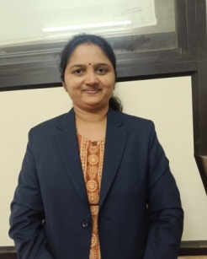
2. | Designation | Assistant Professor
3. | Qualification | MCA
3. | Employee ID
4. | Date of Birth | 27th July, 1991
5. | Contact Details | Mob:9226465271
5. | Contact Details | Email –id:durga.sonawale91@gmail.com
5. Educational Qualification
Sl.No | Specialisation | Institute Name | University | Year of Passing
Ph.D
PG | MCA (Engineering) | SSOCS, Solapur | Solapur | 2015
UG | BCA | NSB College | Phalatan | 2012
Diploma
6. Professional Experience (In Years)
Industrial Expeerience | Teaching Experience | Total
--- | 4 years | 4years
7. Research Credentials
 |  | National | International | Total
A | Papers Published | --- | --- | --
B | Papers Presented | --- | --- | --
C | Book Chapters | --- | --- | --
D | Workshops / FDPs / Seminars attended | --- | ---- | --

7. Workshops / FDPs / Seminars attended
Sl.No. | Name of the Workshop / Conference | Organized by | Place | Date of Workshop / Conference
1
2

