Faculty Profile for College Website
1. | Name of the Faculty | Mr. Aland Somshekhar Rajshekhar | 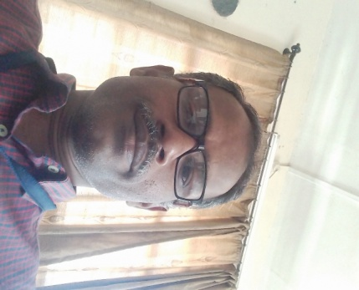
2. | Designation | Assistant Professor
3. | Qualification | MCA
3. | Employee ID
4. | Date of Birth | 08/09/1980
5. | Contact Details | Mob:8275458272
5. | Contact Details | Email –id:somaland80@gmail.com
5. Educational Qualification
Sl.No | Specialisation | Institute Name | University | Year of Passing
Ph.D | NLP, Machine Learning | P.A.H. Solapur University, Solapur | P.A.H. Solapur University, Solapur | pursuing
PG | MCA (Engineering) | Punjab Technical University | Punjab Technical University | 2014
PG | MCA (Science) | Shivaji University | Shivaji University | 2004
UG | B.Sc. (Chemistry) | Sangameshwar College, Solapur | Shivaji University | 2001
Diploma
6. Professional Experience (In Years)
Industrial Expeerience | Teaching Experience | Total
00 | 18 | 18
7. Research Credentials
 |  | National | International | Total
A | Papers Published | 00 | 01 | 01
B | Papers Presented | 00 | 02 | 02
C | Book Chapters
D | Workshops / FDPs / Seminars attended
8. Projects Guided:
UG | PG | Ph.D
9. Major Portfolios handled at College/ Department / University level
10. Funded Projects
Sl. No. | Name of the Supervisors | Project Title | Funding Organisation | Year of Funding with Tenure | Grant Sanctioned (in Rs.)
11. Special Achievements / Awards / Recognitions
12. Professional Body Memberships
13. Research Area: Machine Learning, Artificial Intelligence, Theory of Computation, Compiler Construction
Ph.D Thesis Title: A Novel Approach for Word Sense Disambiguation in Automated Natural
Language Processing
Briefing about Ph.D: The title "A Novel Approach for Word Sense Disambiguation in Automated Natural Language Processing" suggests that it explores innovative methods at the intersection of Natural Language Processing (NLP), Machine Learning, and Deep Learning. In this study, the goal is to tackle the challenge of word sense disambiguation, a crucial task in NLP, by leveraging advanced machine learning and deep learning techniques. This work introduces a fresh and inventive approach to resolve word ambiguities within various contexts, contributing to the advancement of automated NLP systems, which are essential for tasks like language translation, sentiment analysis, and information retrieval.

7A. Papers Published
- “Name of the Author”, “Title of the Paper”, “Name of the Journal”, “Vol”, “Issue”, “Pg.No.”, “Year of Publication”, “DOI/Paper Link”.
Ex: A. Dawood, B. Marti Marti, V. Sauret-Jackson & A. Darwood, “3D printing in dentistry”, British Dental Journal, volume 219, pages 521–529, 2015, DOI: https://doi.org/10.1038/sj.bdj.2015.914
7B. Papers Presented
Sl. No. | Name of the Authors | Title of the Paper | Name of the Conference | Organized by | Place | Date of conference
1 | Somshekhar Aland, Rajivkumar Mente | “Word Sense Disambiguation and It’s Approaches: A Survey”, | ‘Emerging Trends In Science And Technology’ | St. Claret College, Bangalore | Bangalore | 5-6, August 2021
2 | Somshekhar Aland, Rajivkumar Mente, B.D.Chendage | “Review of Word Sense Disambiguation and It’s Approaches”, | International Conference on Computational Intelligence and  Innovative Technologies (ICCIIT – 2022), | Institute of Industrial & Computer Management & Research (IICMR) | IICMR Pune | 16 th and 17th April 2022.
7C. Book Chapters
- “Name of the Author”, “Title of the Paper”, “Name of the Book”, “Vol”, “Pg.No.”, “Year of Publication”, ISBN / ISSN.
7D. Workshops / FDPs / Seminars attended
Sl. No. | Name of the Workshop / Conference | Organized by | Place | Date of Workshop / Conference

