Faculty Profile for College Website
1. | Name of the Faculty | AartiBhargav Patel | 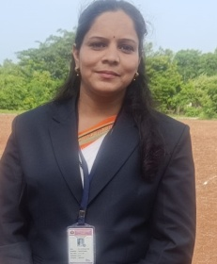
2. | Designation | Assistant Professor
3. | Qualification | MCA
3. | Employee ID
4. | Date of Birth | 27th Oct, 1987
5. | Contact Details | Mob:8275157337, 9284207287
5. | Contact Details | Email –id:aartikalani07@gmail.com
5. Educational Qualification
Sl.No | Specialisation | Institute Name | University | Year of Passing
Ph.D
PG | MCA (Engineering) | BIGCE, Solapur | Solapur | 2011
UG | BCA | HN College, Solapur | Solapur | 2008
Diploma
6. Professional Experience (In Years)
Industrial Expeerience | Teaching Experience | Total
--- | 4 years, 9 months | 4 yrs, 9 months
7. Research Credentials
 |  | National | International | Total
A | Papers Published | 4 | --- | 4
B | Papers Presented | --- | ---
C | Book Chapters | --- | ---
D | Workshops / FDPs / Seminars attended | 2 | ---- | 2

7. Papers Published
- “Aarti Patel”, “Cloud computing Augmenting the Business Growth”, “ICON 2012”, “2012”.
- “Aarti Patel”, “ A study of preventive approach of ICT for women’s security”, “NCIT 2013”, “2013”
- “Aarti Patel”, “A study of attractive android apps and its threatening security issues.”, ”NCIT 2013”, “2013”
- “Aarti Patel”, “E-Management” A critical success factor for E-Business”, “MAMI CTACE 2009”, “2009”
7. Workshops / FDPs / Seminars attended
Sl.No. | Name of the Workshop / Conference | Organized by | Place | Date of Workshop / Conference
1 | Research methodology and statistical analysis | Sinhgad Institute of business management | Kamlapur | 20th and 21st April, 2012
2 | Exploring JAVA | Sinhgad Institute of computer sciences | Korti, Pandharpur | 24th -29th November,2012

